Decision Support Tool (DST)

Software Version 1.1

User Guide



November 2019

Department of Veterans Affairs

Office of Information and Technology (OI&T)

Revision History

NOTE: The revision history cycle begins once changes or enhancements are requested after the document has been baselined.

|  |  |  |  |
| --- | --- | --- | --- |
| Date | Revision | Description | Author |
| 11/25/2019 | 6.0 | Software Version 1.1:   * Updated screen captures. * Updated acronym list. * Added character limit note to the Explanation field under the Best Medical Interest of Veteran section. * Added What’s New? Screen to DST login. * Added Best Medical Interest of Veteran note for signed consult. * Updated Best Medical Interest of Veteran menu options. * Added Capturing Scheduling Information in the VCCPE-Admin Workflow section. * Added Auto-Forward Consult to Community Care features * Removed the Link DST Data Dialog Box | AbleVets |
| 08/06/2019 | 5.0 | Software Version 1.0.12:   * Updated screen captures. * Added What’s New? feature information. | AbleVets |
| 07/16/2019 | 4.0 | Software Version 1.0.09:  Added note regarding the Average Drive Time and Average Wait Time not showing up for Clinical Services that require a manual entry. | AbleVets |
| 05/30/2019 | 3.0 | Software Version 1.0.04:   * Updated name from National Service Desk to Enterprise Service Desk. * Updated the Facility Name description to include the radius for Specialty Care and Primary Care. | AbleVets |
| 05/21/2019 | 2.0 | GMRC*3*129:   * Updated VA Facility search radius to 100 miles. * Updated DST dashboard screens. | AbleVets |
| 04/10/2019 | 1.0 | Initial Documentation Release for DST v1.0.03. | AbleVets |

**Artifact Rationale**

Per the Veteran-focused Integrated Process (VIP) Guide, the User’s Guide is required to be completed prior to Critical Decision Point #2 (CD2), with the expectation that it will be updated as needed. A User Guide is a technical communication document intended to give assistance to people using a particular system, such as VistA end users. It is usually written by a technical writer, although it can also be written by programmers, product or project managers, or other technical staff. Most user guides contain both a written guide and the associated images. In the case of computer applications, it is usual to include screenshots of the human-machine interfaces, and hardware manuals often include clear, simplified diagrams. The language used is matched to the intended audience, with jargon kept to a minimum or explained thoroughly. The User Guide is a mandatory, build-level document, and should be updated to reflect the contents of the most recently deployed build. The sections documented herein are required if applicable to your product.

Table of Contents

1. Introduction 1

1.1. Purpose 1

1.2. Document Orientation 1

1.2.1. Organization of the Manual 2

1.2.2. Assumptions 2

1.2.3. Coordination 2

1.2.4. Disclaimers 2

1.2.4.1. Software Disclaimer 2

1.2.4.2. Documentation Disclaimer 3

1.2.5. Documentation Conventions 3

1.2.6. References and Resources 3

1.3. Enterprise Service Desk and Organizational Contacts 3

2. System Summary 4

2.1. System Configuration 4

2.2. Data Flows 5

2.3. User Access Levels 5

2.4. Continuity of Operation 5

3. Getting Started 5

3.1. Logging On 5

3.2. System Menu 6

3.2.1. DST Dashboard Controls 9

3.3. Exit System 11

4. Using the Software 11

4.1. Launching DST 11

4.1.1. Launching DST from an Unsigned Consult or When Ordering a New Consult 12

4.1.2. Launching DST from Add Comments to Consult 15

4.2. Capturing Information in DST 17

4.2.1. Capturing Provider and Veteran Decision Data 17

4.2.2. Capturing Scheduling Information in the VCCPE-Admin Workflow 21

5. Troubleshooting 26

5.1. Unable to Lookup Clinical Service 26

5.2. MVI Error Handling 27

5.3. ES Error Handling 28

5.4. PPMS Error Handling 29

6. Acronyms and Abbreviations 30

List of Figures

Figure 1: CCAD DST Business Process workflow – Unsigned Order Consult 4

Figure 2: CCAD DST Business Process workflow – Signed Order Consult 4

Figure 3: CCAD DST Data Flow Diagram 5

Figure 4: DST Dashboard Screen 6

Figure 5: Best Medical Interest of Veteran Menu Options 8

Figure 6: DST Dashboard Controls 9

Figure 7: DST: What’s New? Window Example 10

Figure 8: DST Help Window Example 11

Figure 9: Order a Consult 12

Figure 10: MISSION Act Support Message 13

Figure 11: MISSION Act Requires DST Message 13

Figure 12: DST: What’s New? Screen 14

Figure 13: Unsigned Consult/Ordering a New Consult: DST Dashboard Example 15

Figure 14: Consult Toolbox Menu 16

Figure 15: DST: What’s New? Screen 16

Figure 16: DST Dashboard for a Signed Consult 17

Figure 17: Standardized Episode of Care Section 18

Figure 18: Auto-Forward Consult to Community Care Section 18

Figure 19: Auto-Forward Consult to Community Care Not Available Message 18

Figure 20: Populated DST 19

Figure 21: DST Save Success Message 19

Figure 22: Missing Required Fields Message 19

Figure 23: DST Save Failed Error Message 20

Figure 24: CPRS Order a Consult Window: DST Data Displayed in Reason for Request Field 20

Figure 25: DST Data Displayed in Consult Details 21

Figure 26: Admin: DST Dashboard 22

Figure 27: Clinical Service Selected 22

Figure 28: Wait Time Eligible 23

Figure 29: DST Save Success Message 24

Figure 30: Missing Required Fields Message 24

Figure 31: DST Save Failed Error Message 24

Figure 32: CPRS Order a Consult Window: DST Data Displayed in Reason for Request Field 25

Figure 33: Admin: DST Data Displayed in Consult Details 25

Figure 34: Manual Selection of Clinical Service 26

Figure 35: Veteran Identity Error Handling 27

Figure 36: Veteran Eligibility Error Handling 28

Figure 37: VA Facilities Error Handling 29

# Introduction

The Veterans Health Administration (VHA) Office of Community Care has a need for a real-time decision support tool to help VA Providers and Veterans quickly review the criteria proscribed in the VA Mission Act of 2018, determine whether a given Veteran is eligible and would be best served utilizing the Veterans Community Care Program, and document the decision rationale in the Veteran’s health record.

The DST software will:

* Allow the user to view relevant data within the existing CPRS consult order workflow, that helps the Veteran and VA provider decide if a consult service should be referred to the local VA facility, a near-by VA facility via Inter-Facility Consults (IFC), or to a community provider by providing information about the following:
* Drive time standards associated with the requested consult service.
* Average wait times for the requested clinical service at VA facilities near the Veteran’s place of residence. Note, the average wait times may not be used to determine wait time eligibility.
* Veteran’s eligibility for accessing care in the community and their stated preferences (opt-in/out)
* Allow the provider to select the consult decision and enter additional justification text when indicated.
* Based on the decision outcome, provide required information to the Electronic Medical Record (EMR) in order to initiate either an in-house, IFC, or Veteran Community Care Program (VCCP) consult order.
* Document the rationale for the referral decision in the consult record.
* Generate structured text based on the displayed results that can be used for downstream report generation.

## Purpose

The purpose of this document is to provide instruction for utilizing the Decision Support Tool (DST) to standardize and streamline consult management for Community Care.

## Document Orientation

The *Decision Support Tool User Guide* will provide explanations of each screen and of all user interface options within the context of an easy to understand demonstration data scenario.

This document is also designed to provide the user with screen-by-screen “how to” information on the usage of Consult Toolbox.

### Organization of the Manual

**Section 1: Introduction**

The Introduction section provides the purpose of this manual, an overview of the DST software, an overview of the software used, project references, contact information for the user to seek additional information, and an acronyms and abbreviations list for this manual.

**Section 2: System Summary**

The System Summary section provides a graphical representation of the equipment, communication, and networks used by the system, user access levels, how the software will be accessed, and contingencies and alternative modes of operation.

**Section 3: Getting Started**

Information for the Getting Started section provides a general walk-through of the system from initiation through exit, enabling the user to understand the sequence and flow of the system.

**Section 4: Using the Software**

This section gives the user the “how to” information to use DST, including many step-by-step procedures.

**Section 5: Troubleshooting**

This section provides troubleshooting for the DST user.

**Section 6: Acronyms and Abbreviations**

This section provides a list of acronyms and abbreviations found in this document.

### Assumptions

This guide was written with the following assumed experience/skills of the audience:

* User has login credentials for CPRS.
* User has basic knowledge of the CPRS operating system (such as the use of commands, menu options, and navigation tools).
* User has Consult Toolbox v1.9.0054 installed on their machine.
* User has Google Chrome installed on their machine.

### Coordination

N/A

### Disclaimers

#### Software Disclaimer

This software was developed at the Department of Veterans Affairs (VA) by employees of the Federal Government in the course of their official duties. Pursuant to title 17 Section 105 of the United States Code this software is not subject to copyright protection and is in the public domain. VA assumes no responsibility whatsoever for its use by other parties, and makes no guarantees, expressed or implied, about its quality, reliability, or any other characteristic. We would appreciate acknowledgement if the software is used. This software can be redistributed and/or modified freely provided that any derivative works bear some notice that they are derived from it, and any modified versions bear some notice that they have been modified.

#### Documentation Disclaimer

The appearance of external hyperlink references in this manual does not constitute endorsement by the Department of Veterans Affairs (VA) of this Web site or the information, products, or services contained therein. The VA does not exercise any editorial control over the information you may find at these locations. Such links are provided and are consistent with the stated purpose of the VA.

### Documentation Conventions

This manual uses several methods to highlight different aspects of the material.

Table 1. Documentation Symbols and Descriptions

|  |  |
| --- | --- |
| Symbol | Description |
| Triangle with an exclamation point (!) inside to indicate caution for the reader to take special notice of critical information. | **CAUTION:** Used to caution the reader to take special notice of critical information. |

1. Notes are used to inform the reader of general information including references to additional reading material.

### References and Resources

Readers who wish to learn more about DST, Consult Toolbox, and CPRS should consult the following:

* CPRS: Consult/Request Tracking in the VDL: <https://www.va.gov/vdl/application.asp?appid=62>

## Enterprise Service Desk and Organizational Contacts

For issues related to the CC DST that cannot be resolved by this manual or the site administrator, please contact the Enterprise Service Desk at 855-NSD-HELP (673-4357).

# System Summary

## System Configuration

Within the current CPRS order consult workflow, VA providers utilize the DST system to support the decision and election for consult services for a given consult.

Figure 1: CCAD DST Business Process workflow – Unsigned Order Consult

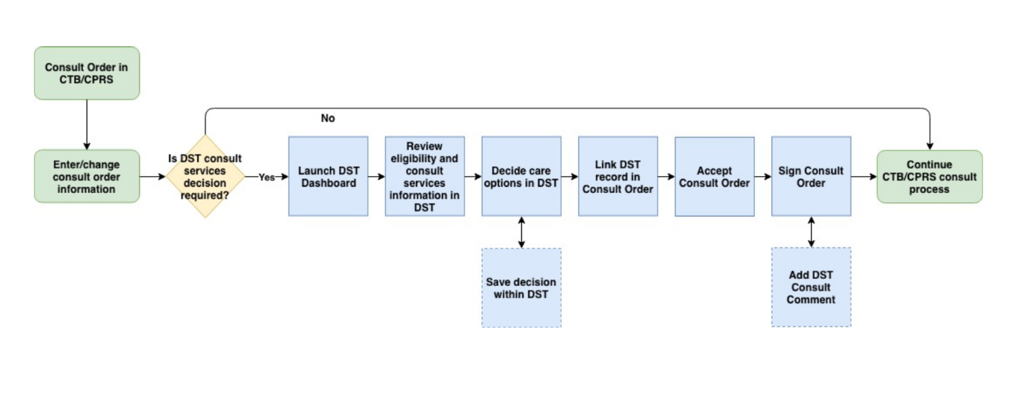

Figure 2: CCAD DST Business Process workflow – Signed Order Consult

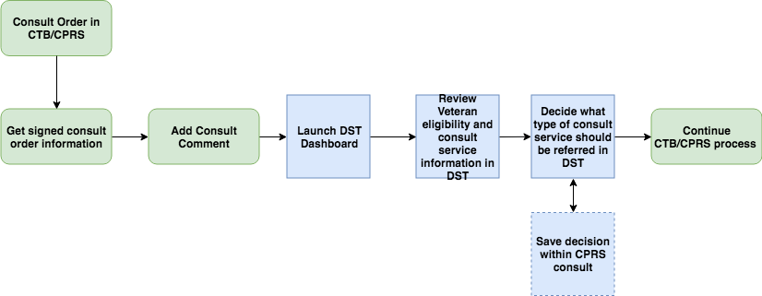

## Data Flows

Figure 3: CCAD DST Data Flow Diagram

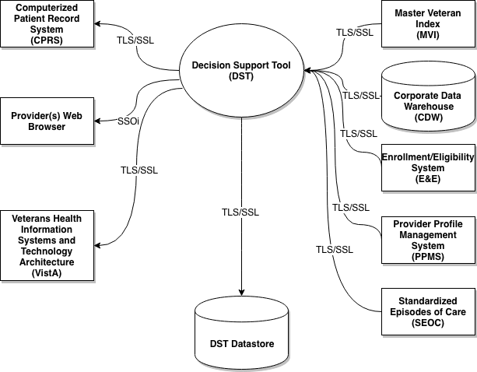

## User Access Levels

All VA providers will serve as the main user base for this system. The user must have access to CPRS and Consult Toolbox must be enabled to access DST.

## Continuity of Operation

DST falls under the VistA Continuity of Operations Plan.

# Getting Started

This section provides a general walkthrough of DST from initiation through exit.

## Logging On

DST is accessed through CPRS.

1. If you have Consult Toolbox v1.9.0054 installed, you will no longer see the standard VA-provided Single Sign-On Integration (SSOi) page when launching DST from CPRS.

## System Menu

The DST Dashboard features three sections: **Consult**, **VA Facilities**, and **Community Care**.

Figure 4: DST Dashboard Screen

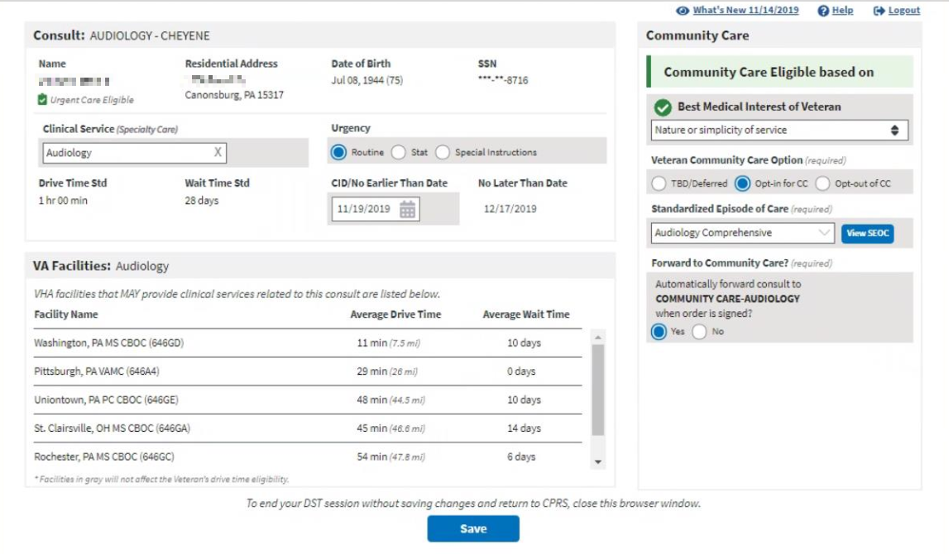

Following are descriptions of the features on the DST Dashboard.

* **Consult** section
* **Name** – Veteran name. This is a read only field supplied by CPRS.
* **Residential Address** – Veterans residential address. This is a read only field supplied by the MVI data interface. Provided by Eligibility & Enrollment System.
* **Date of Birth** – Veterans date of birth. This is a read only field supplied by CPRS.
* **SSN** – Veterans Social Security Number (SSN). This is a read only field supplied by CPRS.
* **Clinical Service** – Consult Clinical Service. Automatically assigned when the user launches DST from CPRS or this field can be manually entered, it depends if you are using an unsigned or signed consult.
* **Urgency** –
  + - **Routine** - Populated by user. A Routine consult indicates the patient should be seen in accordance with the clinically indicated date.
    - **Stat** - Populated by user. Stat consults will be defined as an “immediate” need. The sender of a stat consult is required to:
      * Contact the intended receiver of the consult request to discuss the patients’ situation.
      * Enter “Today” in the clinically indicated date/earliest appropriate date field of the consult.
      * Enter “Stat” in the urgency field of the consult.
      * A stat consult must be completed within 24 hours.
    - **Special Instructions** - Populated by user.
* **Drive Time Std** - This is a read only field supplied by local DST datastore, based on whether the selected clinical service is considered Primary Care/Mental Health or Specialty Care.
* **Wait Time Std** - This is a read only field supplied by local DST datastore, based on whether the selected clinical service is considered Primary Care/Mental Health or Specialty Care.
* **CID/No Earlier Than Date** – As instructed by provider.
* **No Later Than Date** – This field can be modified if the Urgency type **Special Instructions** option is selected.
* **VA Facilities** section: VHA facilities that MAY provide clinical related to this consult are listed in this section. DST searches an internal table (updated weekly from CDW) to filter the returned list to facilities within a 100-mile radius for Specialty Care consults (40-mile radius for Primary Care/Mental Health) that offer services associated with consult Clinical Service (based on the National IFC Dashboard).

1. Average Drive Time and Average Wait Time will not show up until a Clinical Service has been selected, whether by default or via manual entry. The DST application attempts to map consult names to Clinical Services for all Nationwide sites. However, due to the distributed and dynamic nature of consult name addition by the local VA site, DST is not able to keep a real time list of these Consult to Clinical Service mappings. When DST application cannot find a Consult to Clinical Service mapping, the application requires that the user enter the Clinical Service manually on the DST dashboard. When this clinical service is entered, the DST application will continue to request and populate the facility drive time and average wait time based on Residential Address and the entered clinical service.
2. DST may display facilities that are outside the drive time standard so that the Veteran is aware of VA facility options. Facilities displayed that are outside the drive time standard, are not used in the drive time eligibility calculation and will appear in gray text.

* **Facility Name** – List of VHA facilities that offer a related consult service within a 100-mile radius for Specialty Care and a 40-mile radius for Primary Care of the Veteran residential address (sorted by Average Drive Time low-to-high).
* **Average Drive Time** – This refers to the average time it takes to drive from the Veteran’s residential address as noted in the Enrollment System to each identified VA facility that may offer the requested service. This measurement uses VA’s Provider Profile Management System (PPMS) which is a Microsoft-based product that utilizes Bing maps and a proprietary algorithm to determine the time to drive between the two addresses. If PPMS returns 10 facilities or fewer, the drive time calculation takes into account distance, route, speed limits and historical traffic pattern data. If PPMS returns more than 10 facilities, historical traffic data will be excluded from the drive time calculation.
* **Average Wait Time –** This is measured as the average time from the date an appointment is created to the date of the appointment itself. DST displays the average wait times of all new patient appointments completed in the stop code of the requested clinical service, based on new patient appointments in a rolling 30-day assessment. It is possible a facility offers the service requested but has not had any new patients in the last 30 days. In this case, the Average Wait Time field will state Data Not Available. This calculation is similar to the method used for the VA Access to Care public facing website.

It is important to note that average wait time in DST should be used only for reference. It will not be used to establish Community Care eligibility. Community Care wait time eligibility is determined at the time of scheduling the appointment, not at the time of requesting it.

* **Community Care** section: If DST receives a unique Veteran ICN back from MVI, it sends the ICN to the Enrollment System (ES) API to retrieve the Veteran’s residential address and a Veterans eligibility identifying string containing one or more of the following eligibility codes applicable to DST: “U” – Urgent care eligible, “G” – Grandfathered, “H” – Hardship, or “N” – No full-service VHA facility.
* **Best Medical Interest of Veteran** – Drop-down menu. There is a Community Care policy and procedure that allows a VA provider to request the ability for a Veteran to receive care in the community based on that Veterans best medical interest. Congress requests that VA providers consider: **Nature or simplicity of service**, **Frequency of service**, **Need for an attendant**, and **Potential for improved continuity of care**.

1. The Best Medical Interest of Veteran drop-down menu will only display when DST is launched from an unsigned consult if the Veteran is not otherwise eligible.

Figure 5: Best Medical Interest of Veteran Menu Options

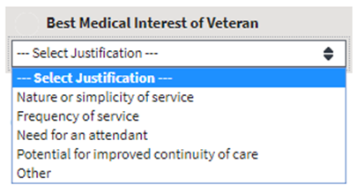

* + - **Nature or simplicity of service**
    - **Frequency of service**
    - **Need for an attendant**
    - **Potential for improved continuity of care**
    - **Other**
* **Explanation (required)** field – Displays only if **Other** is selected from the **Best Medical Interest of Veteran** drop-down menu. (This field has a maximum 200-character limit.)
* **Veteran Community Care Choice (required)** -
  + - **TBD/Deferred** - When this radio button is selected it will require a SEOC to be selected if the Veteran ultimately opts in to Community Care. Because a SEOC is required on every consult that goes to Community Care, this allows the ordering provider to select the appropriate SEOC to match the consult/order that is being ordered at the time it is placed. Additionally, it allows the creator of the consult and thus user of the DST to use information even if the Veteran is a) Not ready to decide or b) Not present. This button then enables the provider to ask a team member to finish the opt in/out decision later while maintaining the integrity of the initial DST dashboard information.
    - **Opt-In for CC** – Veteran elects care in the community.
    - **Opt-out of CC** – Veteran elects to remain within the VA for care.
* **Standardized Episode of Care (required)** – Relates to Clinical Service. A service or group of services the VA authorizes a community provider to perform to complete the consult order including the duration and number of visits that might be necessary. Some or all of the authorized services may need to be performed during any particular episode of care.
* **Forward Consult to Community Care?** – Option to automatically forward consult to Community Care when order is signed.
  + - **Yes**
    - **No**

### DST Dashboard Controls

The DST Dashboard Controls are located at the top right of the DST Dashboard screen.

Figure 6: DST Dashboard Controls



* **What’s New?** – Click **What’s New?** to open the **DST: What’s New?** window. This window lists the new features for each release/build.

Figure 7: DST: What’s New? Window Example

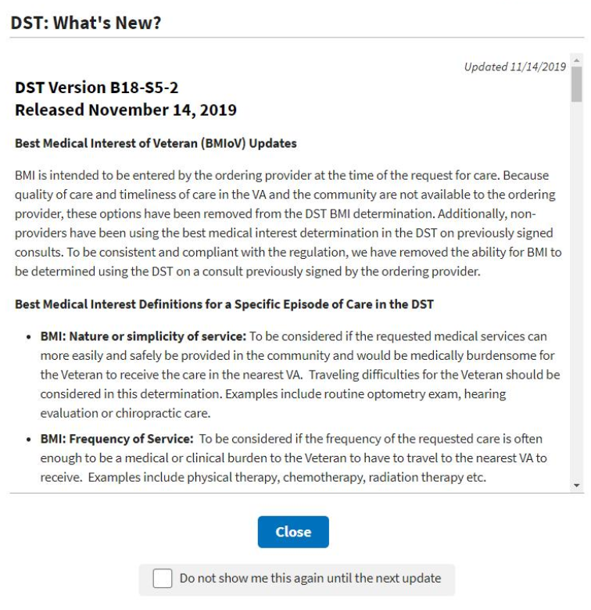

* **Help** – Click **Help** to open a window offering resources for answering questions.

Figure 8: DST Help Window Example

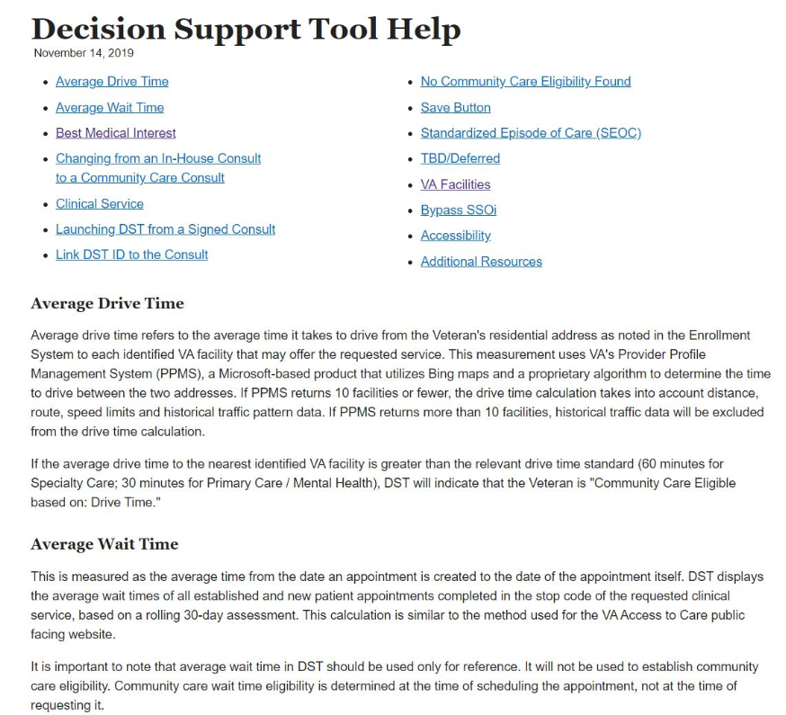

* **Logout** – Click **Logout** to exit out of DST.

## Exit System

To exit DST, click **Logout** at the upper right corner of your screen. To end your DST session without saving changes and return to CPRS, close the browser window.

# Using the Software

## Launching DST

DST can be accessed the following ways:

* Accessing the Decision Support Tool Via an Unsigned Consult
* Accessing the Decision Support Tool when Ordering a New Consult
* Accessing the Decision Support Tool Via Adding a Comment in a Signed Consult

1. When launched, DST will determine if the consult should be opened in the Provider workflow or the Veteran Community Care Program Eligibility (VCCPE)-Admin workflow.

The sections below provide additional information regarding how to launch DST.

1. All examples in this document are representative of test data, no patient Personally Identifiable Information (PII) was used.

### Launching DST from an Unsigned Consult or When Ordering a New Consult

DST can be launched from the **Order a Consult** dialog box from an unsigned consult and when ordering a new consult. When the CPRS window titled **Order a Consult** is active and populated as an outpatient consult without a DST ID already in the Reason for Request, Consult Toolbox displays a message over the **Accept Consult** button while it sends the Consult to Service/Specialty name to DST to determine if the consult is applicable to the MISSION Act.

DST searches an internal table (updated nightly from Corporate Data Warehouse (CDW)) to determine whether the Clinical Service associated with the consult requires DST and returns the result to Consult Toolbox.

If DST returns FALSE, no action is initiated by Consult Toolbox and the consult order workflow continues uninterrupted. If DST returns TRUE or a previous DST ID is found in the Reason for Request field, Consult Toolbox displays a movable, non-modal window to inform the user that the consult should be reviewed for eligibility under the MISSION Act and allows them to open the DST prior to accepting the consult.

Figure 9: Order a Consult

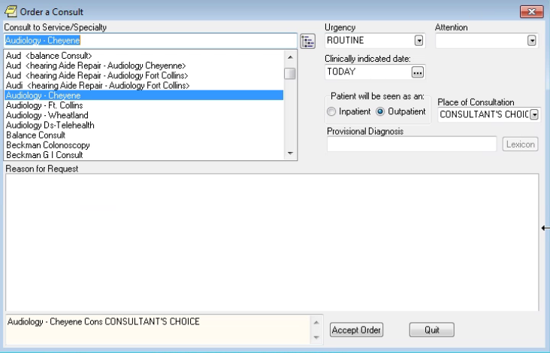

To launch Decision Support Tool (DST) from **Order a Consult**, follow the steps listed below:

1. From the **Order a Consult** window, select an option from the **Consult to Service/Specialty**. If **Outpatient** is selected, then a message stating that it is checking to see if the consult requires MISSION Act support displays.

Figure 10: MISSION Act Support Message

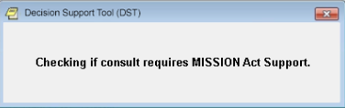

If MISSION Act requires the use of the DST, a message will display.

Figure 11: MISSION Act Requires DST Message

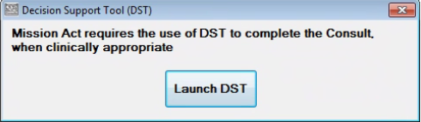

1. Click **Launch DST**. The **DST: What’s New? Screen** displays.

Figure 12: DST: What’s New? Screen



1. If you do not want the DST: What’s New? window to display each time you launch DST, select the **Do not show me this again until the next update** checkbox and the window will only display where there are new DST updates.
2. Click **Close**. The **DST Dashboard** displays.

Figure 13: Unsigned Consult/Ordering a New Consult: DST Dashboard Example

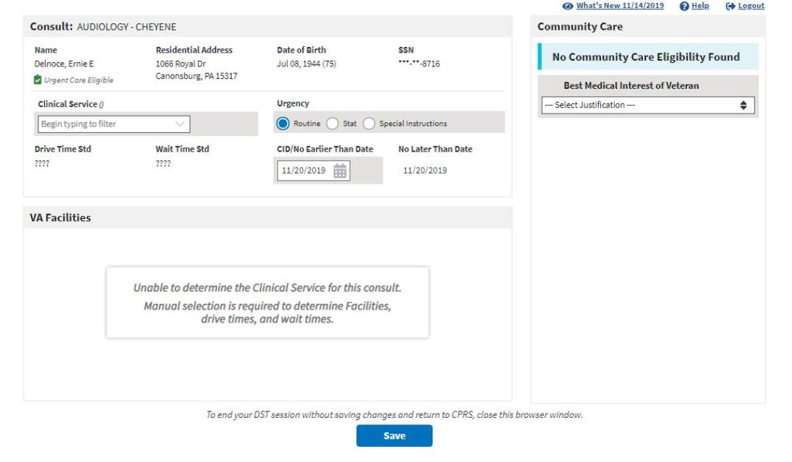

### Launching DST from Add Comments to Consult

DST can be accessed from the Consult Toolbox menu that is displayed when you right-click inside the Add Comment to Consult window in CPRS. When DST is launched this way, the user input data is carried-forward from the most recent DST data set if present.

DST Data is kept in the local database for a period of 30 days after the last update. The data is used to populate the consult comment when the order is signed and to restore the user entries when DST is reopened. If someone opens DST from a consult after the DST data has been deleted, they will see the same as if DST was being opened for the first time on the consult. Eligibility and facility information is always updated in real-time, while the Best Medical Interest of the Veteran, Veteran Community Care Option, SEOC, and Consult Decision will be blank.

To launch Decision Support Tool (DST) from Consult Toolbox Add Comment to Consult, follow the steps listed below:

1. From the **Action** menu, select **Consult Tracking…** > **Add Comment**. The **Add Comment to Consult** window displays the Consult Toolbox menu.

Figure 14: Consult Toolbox Menu

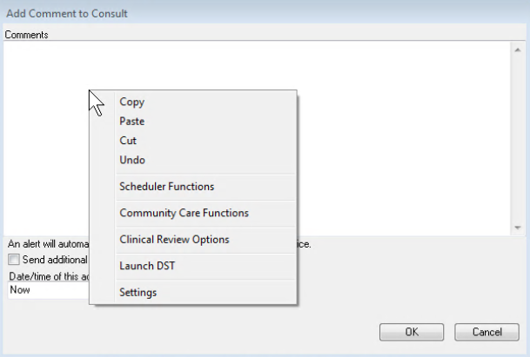

1. From the **Consult Toolbox** menu, select **Launch DST**. The **DST: What’s New? Screen** displays.

Figure 15: DST: What’s New? Screen



1. If you do not want the DST: What’s New? window to display each time you launch DST, select the **Do not show me this again until the next update** checkbox and the window will only display where there are new DST updates.
2. Click **Close**. The **DST Dashboard** displays.

Figure 16: DST Dashboard for a Signed Consult

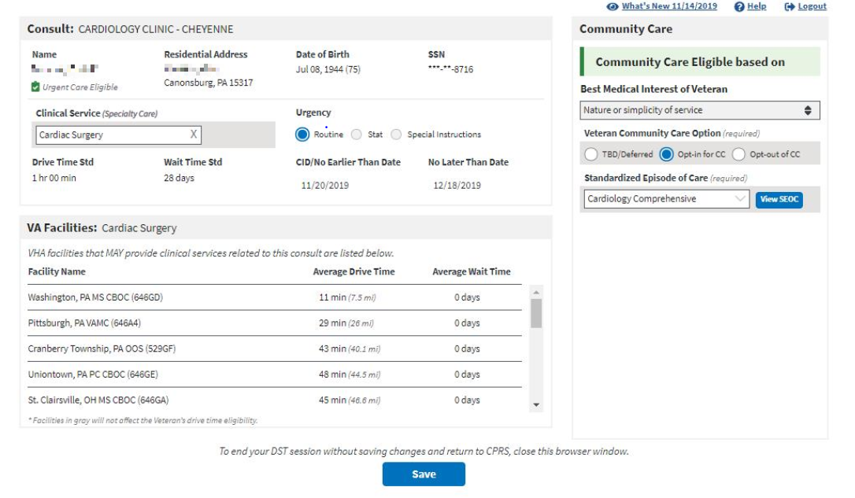

## Capturing Information in DST

### Capturing Provider and Veteran Decision Data

DST allows you to enter additional information required to fully document the decision to order a VA consult or create a Community Care referral. To enter additional information, follow the steps listed below:

1. Under the **Consult** section, enter/update the **Urgency**. If **Special Instructions** is selected, you will need to enter/update the **No Later Than Date** field.
2. Under the **Consult** section, enter/update the **CID/No Earlier Than Date** field.
3. If there are no other Community Care eligibility factors found and the provider and Veteran have agreed that it is in the Veteran’s best medical interest to be seen in the community during this specific episode of care, under the **Community Care** section, select an option from the **Best Medical Interest of Veteran** drop-down menu to establish eligibility. If **Other** is selected, you must enter information in the **Explanation** field.
4. The **Best Medical Interest of Veteran** option will be read-only when the consult has been signed if the value was previously entered otherwise it is not displayed.
5. If the Veteran is eligible for Community Care, from the **Veteran Community Care Choice** area, select the Veteran’s choice to **TBD/Deferred**, **Opt-in for CC**, or **Opt-out of CC**. If you select the Veteran Community Care Choice of **TBD/Deferred** or **Opt-in for CC**, the **Standardized Episode of Care** section becomes visible.

Figure 17: Standardized Episode of Care Section

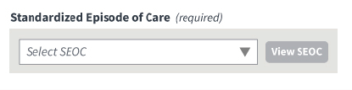

1. If the Veteran is eligible for Community Care and opts-in, from the **Standardized Episode of Care** drop-down menu, select a SEOC to define the authorized care should the consult be forwarded to Community Care. The list of SEOCs is filtered based on the selected Clinical Service (based on government-furnished mapping) to eliminate unrelated SEOCs from the selection list. The SEOC content can be previewed after selection. Once you select the SEOC, the **Forward Consult to Community Care** section becomes visible.

Figure 18: Auto-Forward Consult to Community Care Section

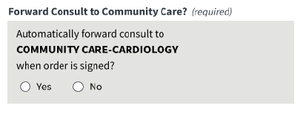

Note, if the selected SEOC is not available for consult forwarding a message will display. Please refer to the DST-Clinical Service Mapping file on the [SharePoint site](https://vaww.vha.vaco.portal.va.gov/DUSHCC/DC/DO/CI/S/Decision%20Support%20Tool/Forms/AllItems.aspx).

Figure 19: Auto-Forward Consult to Community Care Not Available Message

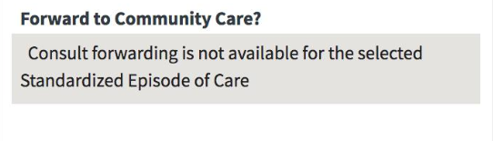

1. DST generates a standard Community Care Consult Name based on the SEOC selected.
2. From the **Forward Consult to Community Care** section, select **Yes** or **No** if you want to automatically forward the consult when the order is signed. If you try to save the DST info before selecting an option, an error message displays prompting you to make the correction before saving.

Figure 20: Populated DST



1. Once the required DST information is populated the save button will enabled. Click **Save DST Info**, the **DST Save Success Message** displays. The information captured on the DST dashboard will now be saved to the consult.

Figure 21: DST Save Success Message

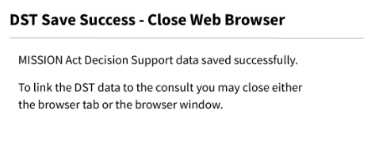

If DST is unable to save due to content missing, the **Unable to Save Message** displays. Update the missing fields and save again.

Figure 22: Missing Required Fields Message

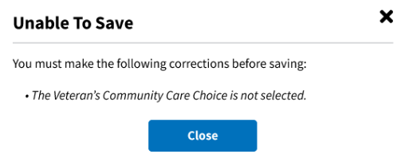

If something went wrong while trying to save, the DST Save Failed Error Message displays.

Figure 23: DST Save Failed Error Message

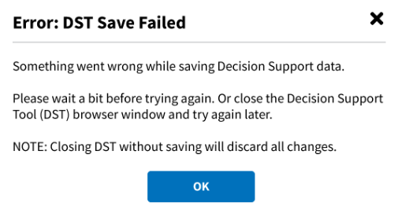

1. To link the DST data to the consult, close the DST Chrome browser tab or close the Chrome browser completely by clicking the **X** in the top right corner. The linked DST data displays in the **Reason for Request** section in the **Order a Consult** window.

Figure 24: CPRS Order a Consult Window: DST Data Displayed in Reason for Request Field

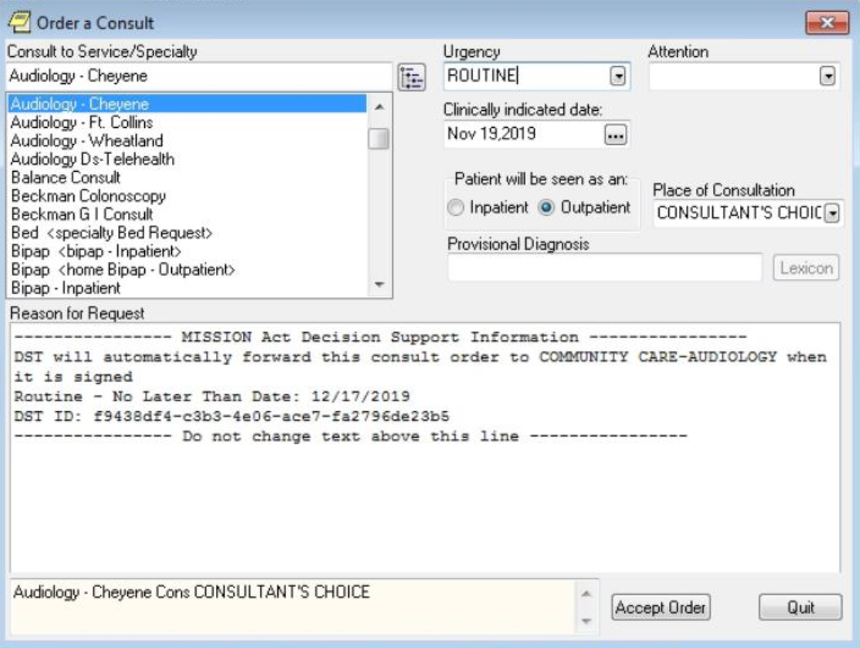

1. Click **Accept Order**. The consult is signed and actual DST information is displayed in the form of a comment. Any changes to DST after a consult is signed will result in a new comment.

Figure 25: DST Data Displayed in Consult Details

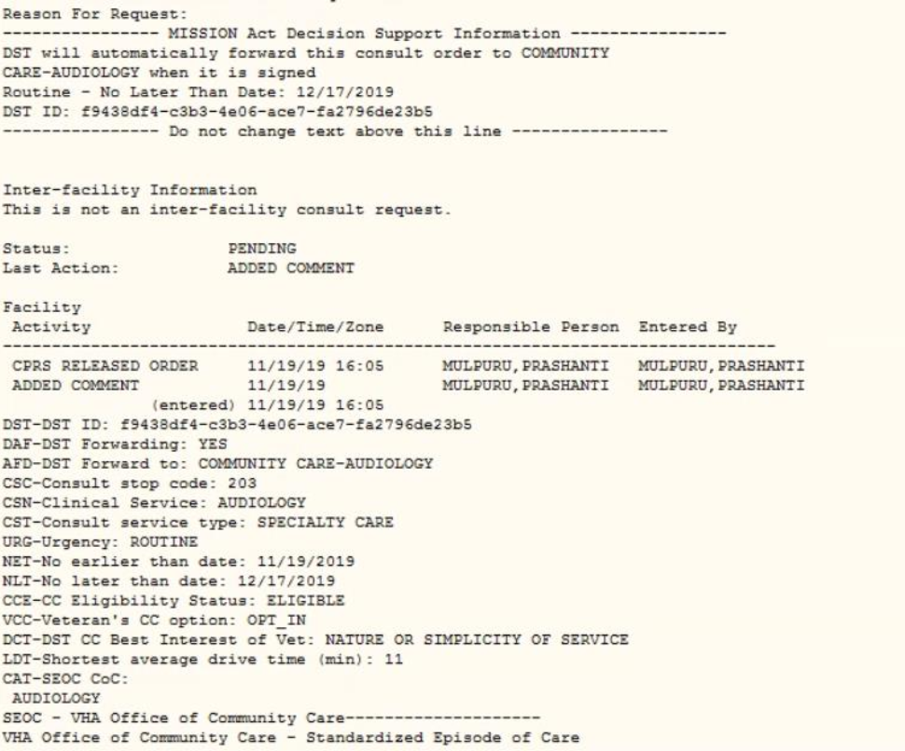

### Capturing Scheduling Information in the VCCPE-Admin Workflow

DST allows you to capture scheduling information in the VCCPE-Admin workflow. To capture the scheduling information, follow the steps listed below:

Figure 26: Admin: DST Dashboard

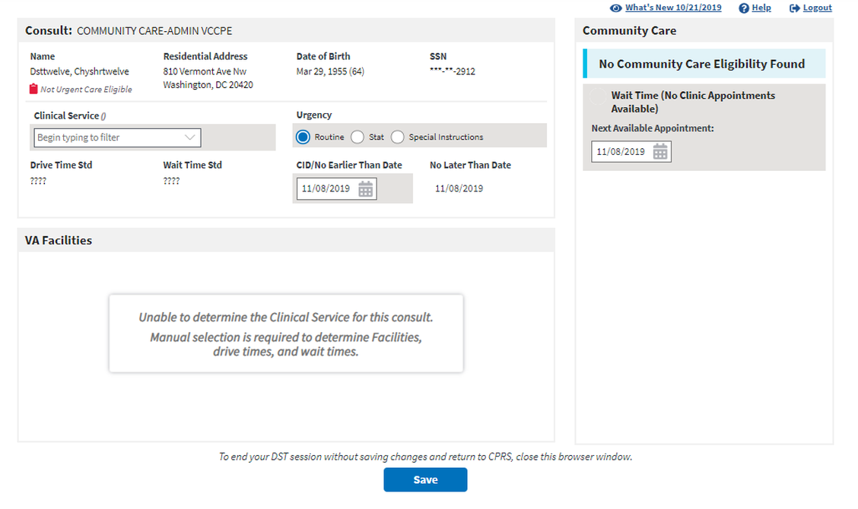

1. Under the **Consult** section, enter/select the **Clinical Services (Specialty Care)** name in the field. The **VA Facilities** section will populate.

Figure 27: Clinical Service Selected

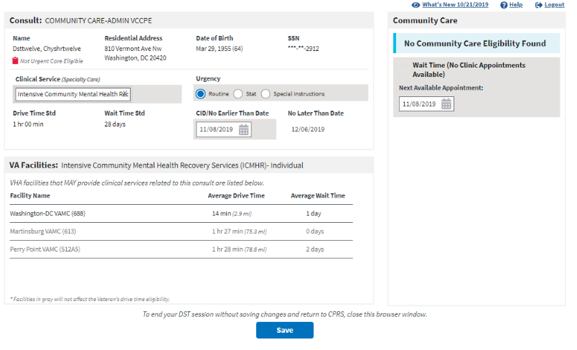

1. Under the **Consult** section, enter/update the **Urgency**.
2. Under the **Consult** section, enter/update the **CID/No Earlier Than Date** field.
3. If **Routine** or **Stat** are selected for **Urgency**, the **No Later Than Date** field will be automatically populated.
4. If **Special Instructions** is selected, you will need to enter/update the **No Later Than Date** field.
5. Under the **Community Care** section, enter/update the **Next** **Available Appointment** field. If the **Next** **Available Appointment** is updated and is after the **No Later Than Date**, then the patient will be **Wait Time (No Clinic Appointments Available)** eligible for Community Care.

Figure 28: Wait Time Eligible

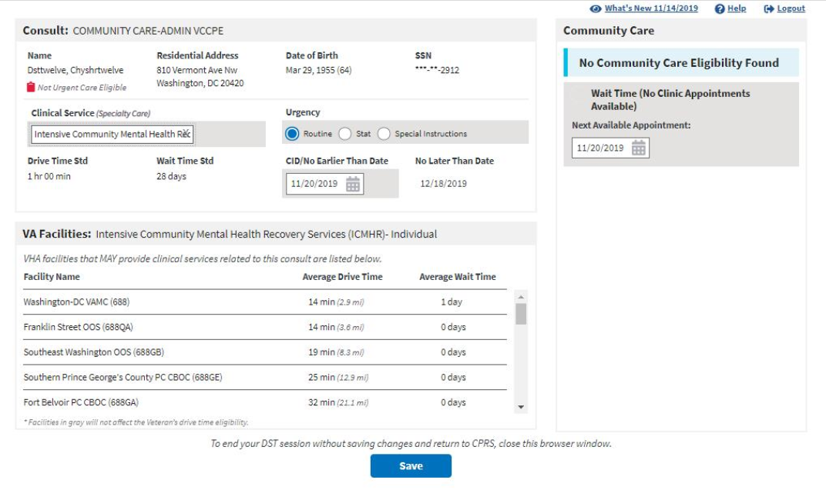

1. If the Veteran is eligible for Community Care, from the **Veteran Community Care Choice** area, select the Veteran’s choice to **TBD/Deferred**, **Opt-in for CC**, or **Opt-out of CC**.
2. Once the required DST information is populated the save button will enabled. Click **Save**, the **DST Save Success Message** displays. The information captured on the DST dashboard will now be saved to the consult.

Figure 29: DST Save Success Message



If DST is unable to save due to content missing, the **Unable to Save Message** displays. Update the missing fields and save again.

Figure 30: Missing Required Fields Message



If something went wrong while trying to save, the DST Save Failed Error Message displays.

Figure 31: DST Save Failed Error Message



1. To link the DST data to the consult, close the DST Chrome browser tab or close the Chrome browser completely by clicking the **X** in the top right corner. The linked DST data displays in the **Reason for Request** section in the **Order a Consult** window.

Figure 32: CPRS Order a Consult Window: DST Data Displayed in Reason for Request Field

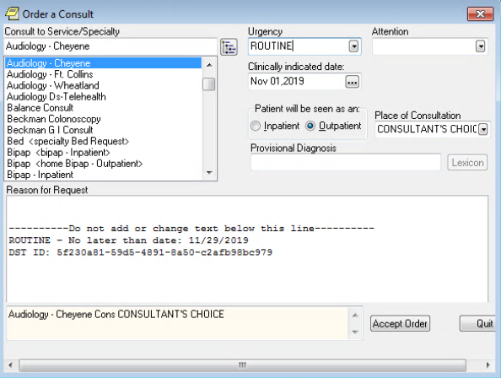

1. Click **Accept Order**. The consult is signed and actual DST information is displayed in the form of a comment. Any changes to DST after a consult is signed will result in a new comment.

Figure 33: Admin: DST Data Displayed in Consult Details

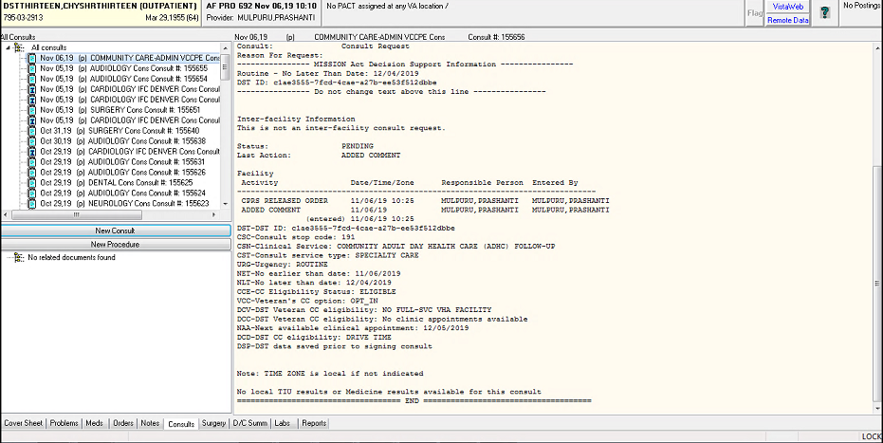

# Troubleshooting

## Unable to Lookup Clinical Service

Concurrent to the remote data calls, DST searches an internal table (updated nightly from CDW) to get the Clinical Service for the selected consult and sets the consult type to Primary Care/Mental Health (PC/MH) or Specialty Care (SC) based on government-provided mapping data. If the Clinical Service cannot be identified from the CDW tables, a message will be displayed in the VA facilities area to prompt the user to select the Clinical Service manually.

Figure 34: Manual Selection of Clinical Service

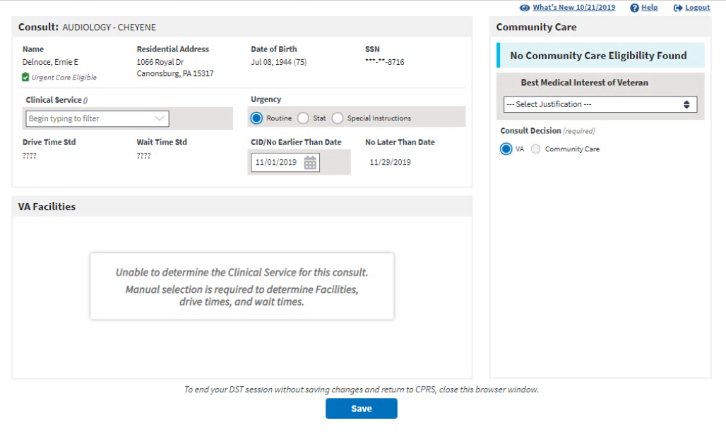

## MVI Error Handling

If MVI does not respond within 10 seconds or a single exact match ICN is not returned, an error message is displayed to the user, the error code is logged in the DST database, the rest of the remote data calls are skipped, and the user can continue with the DST workflow. The specific error code will be stored in the DST database and added to comments after consult is signed to support analytics/reporting.

Figure 35: Veteran Identity Error Handling

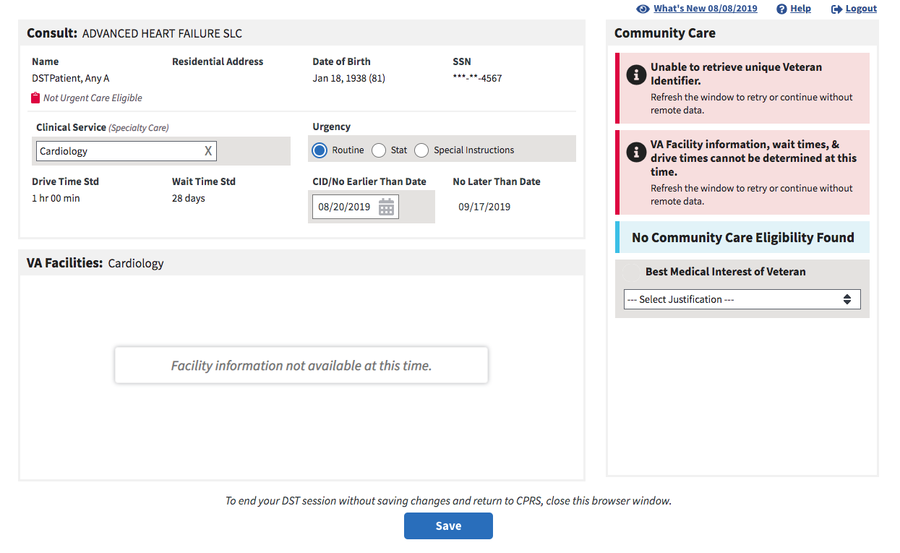

## ES Error Handling

If ES does not respond within 10 seconds or the Veteran ICN is not found, an error message is displayed to the user, the error code is logged in the DST database, the rest of the remote data calls are skipped, and the user can continue with the DST workflow. The specific error code will be stored in the DST database and added to comments after consult is signed to support analytics/reporting.

Figure 36: Veteran Eligibility Error Handling

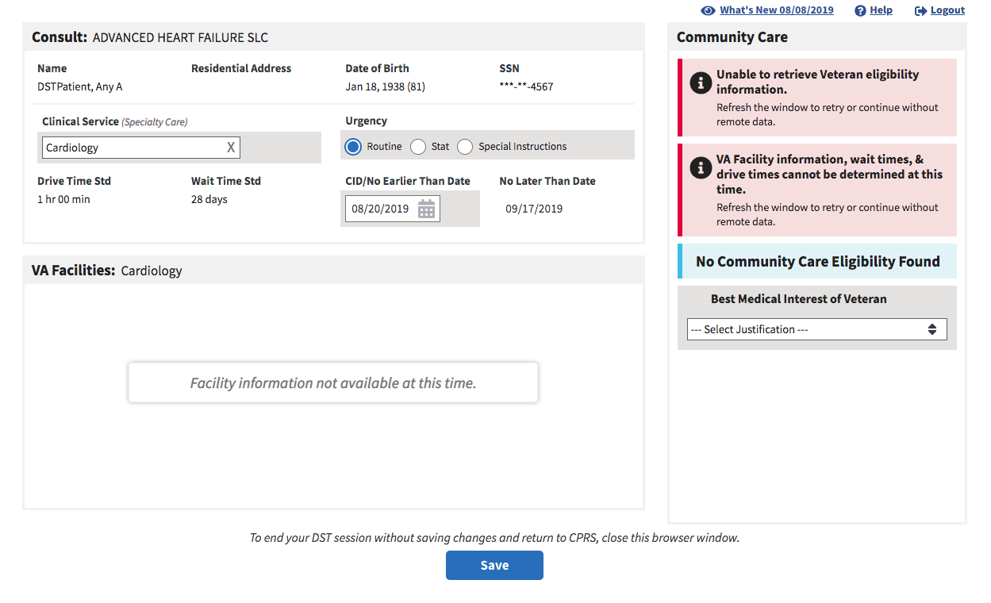

## PPMS Error Handling

If PPMS does not respond within 10 seconds an error message is displayed to the user in the VA Facilities section, the error code is logged in the DST database, Drive Time and Wait Time VCEs displayed with error icons, and the user can continue with the DST workflow. The specific error code will be stored in the DST database and added to comments after consult is signed to support analytics/reporting.

Figure 37: VA Facilities Error Handling

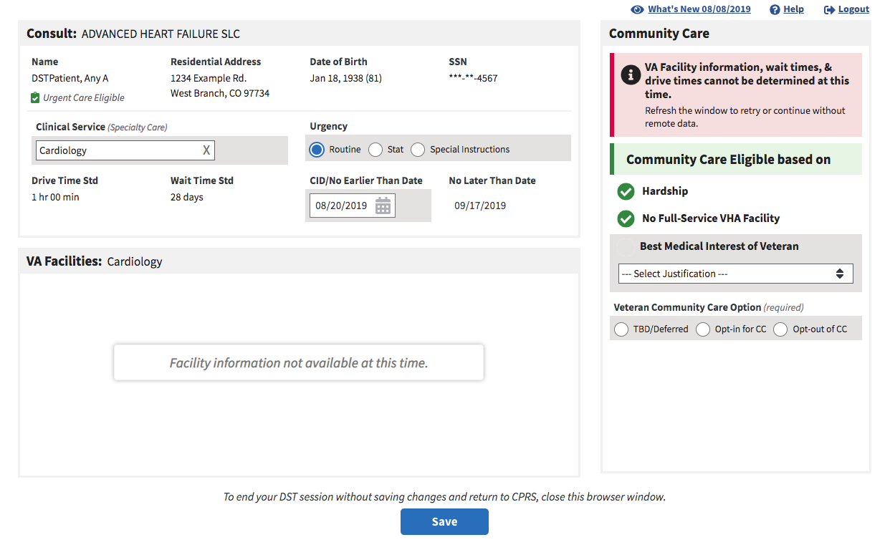

# Acronyms and Abbreviations

Table 2. Acronyms and Abbreviations

|  |  |
| --- | --- |
| Acronym | Definition |
| CD2 | Critical Decision Point #2 |
| CDW | Corporate Data Warehouse |
| CPRS | Computerized Patient Record System |
| DST | Decision Support Tool |
| E&E | Enrollment and Eligibility |
| EMR | Electronic Medical Record |
| FOIA | Freedom of Information Act |
| FQDN | Fully Qualified Domain Name |
| ID | Identification |
| IFC | Inter-Facility Consults |
| IP | Internet Protocol |
| IT | Information Technology |
| MVI | Master Veteran Index |
| OI&T | Office of Information and Technology |
| OMB | Office of Management and Budget |
| OSEHRA | Open Source Electronic Health Record Agent |
| P&LMS | Pathology and Laboratory Medicine Service |
| PII | Personally Identifiable Information |
| PPMS | Provider Profile Management System |
| SEOC | Standardized Episodes of Care |
| SSL | Secure Socket Layer |
| SSOi | Single Sign On Integration |
| TLS | Transport Layer Security |
| URL | Uniform Resource Locator |
| VA | Department of Veterans Affairs |
| VCCP | Veteran Community Care Program |
| VDL | VA Software Document Library |
| VHA | Veterans Health Administration |
| VIP | Veteran-focused Integrated Process |
| VistA | Veterans Health Information Systems and Technology Architecture |